Article

IoT monitoring of tree ecosystem services in urban green infrastructures: possibilities and challenges

Matasov V.1, Yaroslavtsev A. 1., Sala G.1,2, Fareeva O.1, Seregin I.1, Belelli Marchesini L.1,3,

Castaldi S., 1,4,Vasenev I.V.1, Valentini R.1,5,6

1RUDN University, Moscow, Russian Federation

2University of Palermo, Italy

3Mach Foundation, Trento , Italy

4University of Campania “Luigi Vanvitelli”, Caserta, Italy

5University of Tuscia , Italy

6 CMCC Foundation, Lecce, Italy

**Abstract.**

Urban green spaces play an essential role in the sustainable functioning of urban ecosystems and provide the most important regulating and cultural ecosystem services. Meanwhile cities are entering a new age of widespread data collection, processing, and utilization in urban decision-making. It is necessary to expand the uses of digital and computing technologies to green infrastructure management, as it is a crucial component for human well-being under the rapid urbanization.

The Bolotnaya square – small green area (370m length and 120m width) situated on the island Balchug in the center of Moscow – was chosen as a study site that represents urban green infrastructure under the high influence of urban heat island and high level of anthropogenic load. . For real-time monitoring sixteen TreeTalkers that provide data on physiological conditions of a single tree were installed to describe different species in their local conditions. All measurements were conducted from 1 July to 31 November with 1.5 hour time resolution. We used R programming language for all data processing. To move from parameters of trees functioning to provided ecosystem services we established several indicators related to climate, air and water regulation.

Our results show that the average tree in Moscow center during investigated period reduced extreme heat on 2℃ degree and cooled down the area by consuming energy on 4900KWh, transpires 160 mmof precipitation water, deposits 12 kg of Carbon and absorbs 4.5 kg of PM10. But the real values for different species vary (up to five-ten times) under the influence of local conditions and also depends substantially on seasonal and weather changes. Thus, it is crucial to use real-time monitoring data to understand deeper the processes in urban forests. There is a new opportunity of applying IoT technology not only to measure the functioning fluxes, but to establish a smart urban green infrastructure management based on ecosystem services indicators.

**Key words**: Ecosystem services, Ecological engineering, Green infrastructure, Real-time monitoring, Smart monitoring, Smart cities, Sustainability, TreeTalker, Trees, Urban forests.

**1. Introduction**

*1.1. Urban growth and how people depend on ecosystem services*

Urbanization is increasing on a global scale, and today more than half of the world's population lives in cities and more than two thirds are expected to live in cities by 2050 (Dye, 2008). Concentration of population in cities plays a significant role in fostering economic development and encouraging innovation due to economies of scale (Bettencourt et al., 2007). In addition this process may also have negative effects on many aspects of human well-being, including increasing crime rates (Bettencourt et al., 2007) and growing health risks (Frumkin, 2003; Lederbogen et al., 2011). Moreover, it was shown that urban areas significantly contribute to climate change and global carbon emissions, ecosystem degradation and biodiversity loss on a global scale (Grimm et al., 2008; Seto et al., 2012). It is well-known that people living in urban areas depend on natural ecosystems not only within the city limits, but also beyond the urban area (Bolund and Hunhammar, 1999) thus demands on natural capital and ecosystems services keep increasing steadily (Guo et al., 2010; Krausmann et al., 2018).

*1.2. Ecosystem services concept as a key to sustainable urban planning.*

The ecosystem services (ES) concept, which emerged from ecological economics in 1990s, allows to understand and explain human-environmental interactions complexity if we want to balance interlinked sustainable goals in landscape planning (Vihervaara et al., 2019; Wilkinson et al., 2013). It is widely discussed that ES concept could be used as a new Esperanto (Spyra et al., 2019) because of its communicative power in participatory planning processes (Haaren et al., 2019; Opdam et al., 2018). But such comprehensive planning approach requires planners to assess and value nature’s contributions to the human well-being (Gómez-Baggethun and Barton, 2013; UNEP, 2010), especially in a cities as a coupled human-environment systems (Wu, 2013). The concept of ES and its application to urban environments were addressed by major initiatives like the Millennium Ecosystem Assessment and The Economics of Ecosystems and Biodiversity, and have gained increasing attention in literature (Bolund and Hunhammar, 1999; Haase et al., 2014; Kremer et al., 2016) and in a policy debate on green infrastructure (Burkhard et al., 2018). However, ES concept might be too complex and sometimes does not meet the real world and requirements for planning applications, and even might be misinterpreted in practice (Czúcz et al., 2018; La Rosa et al., 2016; Luederitz et al., 2015). It is common situation when decision-makers pay attention to visible and directly usable ES, which are mainly provisional and cultural ES and underestimate the value of regulating and habitat ES (Mascarenhas et al., 2016; van Oudenhoven et al., 2018; Wissen Hayek et al., 2016).

*1.3. Regulating ES from GI and ways to assess it.*

Urban green infrastructure (UGI) play an essential role in the sustainable functioning of urban ecosystems and provide the most important regulating and habitat ecosystem services such as carbon sequestration, microclimate formation, pollution and dust reduction in atmospheric air, water balance control, wildlife habitat, wind and noise reduction, etc. (Andersson et al., 2014; Gómez-Baggethun and Barton, 2013; Lovell and Taylor, 2013). The magnitude of the ES provided depend on the characteristics of UGI, such as vegetation type, age, structure and management practices, which is important compare to natural ecosystems. This may cause a trade-off between which service is maximized (Bodnaruk et al., 2017), or between ecosystem services and disservices (Speak et al., 2018; Teixeira et al., 2019) and could be a reason for cost-benefit analysis (Song et al., 2018; von Döhren and Haase, 2019). There are several studies that assess ES in different types of UGI (Blanusa et al., 2019; Lovell and Taylor, 2013; Nowak et al., 2006), in areas with the same typology but different types of management (Lilly et al., 2015; Schwilch et al., 2018) or in different types of vegetation within the same area (Mexia et al., 2018). Several types of models such as Artificial Intelligence for Ecosystem Services (ARIES) and the Integrated Valuation of Ecosystem Services and Tradeoffs (InVEST) identifies ES via proxies, typically land-use/cover, based on expert knowledge and causal relationships. Urban ES assessing presents a special case due to the high, fine-resolution spatial heterogeneity of these landscapes that could lead to high mapping error (Zhao and Sander, 2018). That is why to better understand the ES provided by UGI researchers conducted direct measurements of different processes (Nowak et al., 2006; Nowak and Crane, 2002), and its modeling (Lin et al., 2019; Rötzer et al., 2019) on a tree-level, which yielded in wide spreading use of software and tools, such as i-Tree model (<http://www.itreetools.org>).

*1.4. Process-Indicator-Value. How to find a clear and useful indicators of ES.*

Our understanding of the relationships between functional fluxes in ecosystems and services they provide is still very incomplete (Drobnik et al., 2018; Van Reeth, 2013). To overcome this high complexity in human-environmental systems scientists use ecological indicators that generally are variables that provide aggregated information on certain phenomena (Müller and Burkhard, 2012). For the ES assessment the importance of developing appropriate indicators has been recognized (Burkhard et al., 2018; van Oudenhoven et al., 2018) and many ES indicators have been developed, applied, tested and reviewed (Gómez-Baggethun and Barton, 2013; La Rosa et al., 2016; Wissen Hayek et al., 2016). ES indicators need to be relevant to specific purpose (e.g. to reflect difference in land management - van Oudenhoven et al. 2012) or component (e.g. soils - Andrea et al. 2018; Drobnik et al. 2018) or spatial-temporal scale (Aalders and Stanik, 2019; Norton et al., 2016) to avoid uncertainties from that side, but at the same time ES indicators should inform decision making (Czúcz et al., 2018; Willcock et al., 2016). It’s completely clear for decision-makers that “you cannot manage what you do not measure”, thus these indicators should be linked to measurable policy targets and should help to monitor policy progress. And from another side we see a growing interest from citizens to the widespread measurements of the environmental conditions they are living in (Njue et al., 2019; Schröter et al., 2017), so it is also necessary to create clearly understandable indicators for involving people. We should also take into account fast development of cutting-edge technologies of observation, modeling, computing and even acting in a new Industry 4.0 world (Nitoslawski et al., 2019).

*1.5. Smart Urban Forest and trends in technologies.*

The widespread integration into the urban environment of Information and Communication Technologies (ICTs) and Internet of Things (IoT) tools makes our cities “smart” (Albino et al., 2015). Smart technologies are already being applied in environmental management. The species and structure of individual trees was mapped and assessed with remote sensing, aided by machine learning (Alonzo et al., 2014). Forest regeneration was assisted by drones or unmanned aerial vehicles (UAVs) through surveying, fertilizer spraying, and precision aerial seeding (Elliott, 2016). Wireless sensor networks have been deployed in greenhouse settings to measure and regulate environmental parameters (Mesas-Carrascosa et al., 2015). Acoustic sensors were used to assess the urban noise pollution (Farina et al., 2014; Mydlarz et al., 2019). The huge data collected through these technologies provide more insight into the UGI and can be used in analysis, modeling, and prediction (Kitchin, 2014). Traditional monitoring methods do not allow assessing the state of UGI with the spatial-temporal resolution needed for the diagnosis of stressful situations and for decision-making on the management and development of an urban environment. Such new smart digital technologies can be used as tools to improve the human well-being through balancing the ES provided by UGI. The use of wireless network sensors and data loggers can provide information about environmental parameters at a local scale and its visualization in real time (Kitchin, 2014; Nitoslawski et al., 2019).

So, the aim of this work is to show the possibilities and discuss the challenges of real-time tree-level monitoring of ecosystem services in urban conditions. We decided to:

* 1) test the real-time monitoring technology by measuring trees functioning parameters in different conditions
* 2) justify the indicators that can be useful to interpret measurements in terms of ecosystem services
* 3) analyze local factors influencing ecosystem services

**2. Materials and Methods.**

2.1. Study site and installations

Bolotnaya square is a small green area (370m length and 120m width) situated on the island Balchug in the center of Moscow (Figure1), 600m to the south from the Kremlin. Now it’s became well-known through meetings of political opposition. This site located only 700m to the west from Balchug meteorological station that provided data each 3 hours. Study area represents urban green infrastructure under the high influence of urban heat island and high level of anthropogenic load. The main works on its improvement (tree planting) were completed by 1948. So, it was possible to analyze the influence of local biotic factors (species, height, local neighborhood standing conditions, age).

Figure1. Study area.

Sexteen TreeTalker+ (TT+) devices were installed on the trees: 5 on *Acer platanoides* (average DBH 38.7 cm), 3 on *Betula pendula* (average DBH 21.8 cm), 3 on *Larix sibirica* (average DBH 32.1 cm) and 5 on *Tillia cordata* (average DBH 34.1 cm). During the first observation all trees were characterized by height, diameter, age group, VTA score, (ranging from 1 (healthy conditions) to 7 (severe decline) and standing type (table 1).

Table 1. Basic characteristics of the trees.

|  |  |  |  |  |  |  |  |
| --- | --- | --- | --- | --- | --- | --- | --- |
| **Tree ID** | **Species** | **Height, m** | **Diameter, cm** | **Age** | **Canopy area, m2** | **Standing type** | **VTA score** |
| 218A0281 | *Acer platanoides* | 14 | 45.83 | 50-60 | 35.8 | Inner group | 4 |
| 218A0077 | *Acer platanoides* | 20 | 35.65 | 50-60 | 55.7 | Inner group | 2 |
| 218A0262 | *Acer platanoides* | 14 | 34.69 | 50-60 | 28.5 | Edge group | 1 |
| 218A0255 | *Acer platanoides* | 21 | 34.37 | 50-60 | 55.3 | Inner group | 2 |
| 218A0212 | *Acer platanoides* | 15 | 33.74 | 50-60 | 27.6 | Inner group | 3 |
| 218A0285 | *Betula pendula* | 11 | 23.87 | 50-60 | 8.2 | Inner single | 1 |
| 218A0104 | *Betula pendula* | 11 | 21.65 | 30-40 | 7.6 | Inner group | 1 |
| 218A0210 | *Betula pendula* | 11 | 21.00 | 30-40 | 6.4 | Inner group | 1 |
| 218A0138 | *Larix sibirica* | 19 | 40.74 | 80-100 | 37.4 | Inner group | 2 |
| 218A0079 | *Larix sibirica* | 25 | 32.14 | 80-100 | 65.9 | Inner group | 3 |
| 218A0277 | *Larix sibirica* | 24 | 26.10 | 80-100 | 32.3 | Inner group | 2 |
| 218A0186 | *Tilia cordata* | 17 | 40.42 | 50-60 | 19.5 | Edge group | 3 |
| 218A0121 | *Tilia cordata* | 16 | 37.87 | 50-60 | 31.3 | Inner group | 1 |
| 218A0153 | *Tilia cordata* | 14 | 35.33 | 40-50 | 21.1 | Edge group | 2 |
| 218A0111 | *Tilia cordata* | 12 | 28.01 | 40-50 | 20 | Edge group | 3 |
| 218A0270 | *Tilia cordata* | 11 | 25.14 | 30-40 | 22.4 | Inner single | 3 |

The TreeTalkers devices (TT+) (Nature4.0 BC SRL-www.nature4.org, Valentini et al. 2019) are microprocessor based IoT platform built around the ATMEL328 chip, equipped with a LoRa transceiver for radio transmission to a central gateway which collect the individual tree data and send to cloud using GSM/GPRS technology. The TT+ sensors are able to measure: 1) the sap flow density, using a transient thermal dissipation methods based on an heating/cooling cycle of 10minutes every 1 hour (Do et al., 2018), 2) the light transmission spectra through the canopy in 12 spectral bands , using 2 spectrometers (VIS and NIR), 3) diameter growth with an optical IR pulsed device, 4) Stem position and oscillation in 3 axis with an on board accelerometer. In addition air temperature and humidity is recorded at the single tree level. Specifications are listed in Table 2.

Table 2. Measured parameters according to TT+ specification.

|  |  |  |
| --- | --- | --- |
| **Sensor** | **Range** | **Accuracy** |
| Accelerometer | 0-360° (0-8g) | ± 0.01° |
| Diameter growth sensor | 0-1 cm | ±200  |
| Temperature probes | -40 ÷ +40 °C | ±0.1 °C |
| Stem humidity probe | 0 – 100% | ± 2% v/v |
| Visible Spectrometer | 400-700 nm | ± 5 nm peak  ± 20 nmHBW  (450,500,550,570,600,650 nm) |
| Near-Infrared Spectrometer | 700- 900 nm | ± 5 nm peak  ± 10 nmHBW  (610,680,730,760,810,860 nm) |
| Air and humidity sensor | -10 ÷ +85  0-100% | ± 0.5 °C  ± 5% |

A reference device TT+ (TT-R) was mounted outside of the tree canopies to collect climate data and incoming solar radiation reference spectra.On individual trees, the devices were placed at a height of 3 m from the ground on the north side of the trunk and the batteries - on the south side, which reduces the risk of damage or theft of devices. All measurements were conducted from 01 July till 31 November with 1,5 hour temporal resolution.

2.2. Justification of the ES Indicators.

There is a wide range of existing ES indicators, thus we have tried to choose from existed literature (Andersson-Sköld et al., 2018; Gómez-Baggethun and Barton, 2013) the ones that can be directly estimated by our measured parameters. The ES indicators and the relative measured vatiables, including algorithms references are shown on table 3. Direct measurements (like air temperature or relative humidity) gave us an opportunity to calculate ESI without any additional assumptions. However all the ESI that is labeled as “indirect” required us to introduce some adjustment factors or assumptions. Several ESI could be calculated easily via using LAI, but not for all of them we had enough information (e.g. gas concentrations in the air or noise level) and possibilities to verify the results, so we decided to show only LAI dynamics instead of providing absolute values. We present particulate adsorption as an example of usefulness of LAI indicator indirect use.

Table 3. Indicators of ES, provided by urban trees

|  |  |  |  |  |  |  |
| --- | --- | --- | --- | --- | --- | --- |
| **ES group** | **Type of ES** | **Indicator** | **Sensor** | **Type of equation** | **Units** | **Key references** |
| Global Climate regulation | Carbon sequestration | Tree growth rate | IR growth sensor | Indirect | kg C | (Gratani and Varone, 2006; Lindén et al., 2020; Nowak and Crane, 2002) |
| Local Climate regulation | Cooling Effect | Temperature reduction | Thermo-hygrometer | Direct | C degrees | Land surface temperature and climate comfort level (Krayenhoff et al., 2020; Marando et al., 2019; Morakinyo et al., 2020) |
| Energy consumption | Thermo-hygrometer | Indirect | KWh | Exergy (Puzachenko et al., 2013, 2014), Energy balance (Krayenhoff et al., 2020) |
| Humidity reduction | Humidity reduction | Thermo-hygrometer | Direct | % | Humidity control (Chen et al., 2019; Moghbel and Erfanian Salim, 2017) |
| Wind reduction | Wind velocity reduction | Spectrometer | Proxy  ~LAI | % | Wind comfort level (Hefny Salim et al., 2015; Kang et al., 2020; Lee et al., 2010) |
| Water regulation | Run-off mitigation | Evapotranspiration | Thermo-hygrometer probes | Indirect | m3/hr and mm | (Chen et al., 2019; Urban et al., 2019) |
| Rain buffer | Spectrometer | Proxy  ~LAI | % | Rainfall buffer (Pereira et al., 2009; Valente et al., 2020) |
| Air quality regulation | Particulate adsorption | PM removal | Spectrometer | Indirect | g tree-1 | (Hirabayashi et al., 2012; Nowak et al., 2018, 2006; Sæbø et al., 2012) |
| Gas regulation | Gas removal | Spectrometer | Indirect ~LAI | g |
| Human health regulation | Acoustic environment regulation | Noise reduction | Spectrometer | Proxy  ~LAI | % | (Martens and Michelsen, 1981; Van Renterghem, 2014; Yang et al., 2013) |

*2.2.1. Carbon sequestration*

Carbon sequestration assessment was based on IPCC 2006 approach utilizing biomass expansion factors (BEF):

|  |  |
| --- | --- |
| ΔC = [ΔV * BCEF] * (1 + R) * CF, | (1) |

where BCEF = BEF * D and R (root to shot ratio) was taken from literature according to species and age of the tree (Schepaschenko et al., 2018), CF (biomass conversion into carbon) was taken as 0.5. Trunk volume was calculated by using height measured directly in field and trunk diameter expansion measured in real time with TreeTalkers IR distance sensor. Species dendrometric coefficients have been taking into account for the estimation of the trunk shape in the final calculation of biomass increment.

*2.2.2. Air temperature and humidity reduction*

We have used direct measurements of temperature and humidity changes based on the difference between data form thermo-hygrometers of individual TT, measuring climate parameters at 3 m height under the crown space and TT-R (reference outside station).

*2.2.3. Run-off mitigation via evapotranspiration*

Transpiration via Sap Flow (cumulative or hourly)

*2.2.4. Energy consumption*

The energy absorbed by tree is the result of this equation:

|  |  |
| --- | --- |
| Rn= E + H + G, | (2) |

where E is energy spent in transpiration ( the latent heat for vaporization of water = 2264.705 KJ/Kg), H is the sensible heat, the heat transferred or absorbed by the tree by convective heat transfer, G is the heat transferred to the soil by absorption of the energy which penetrate the canopy.

Sensible heat was calculated according to the equation:

|  |  |
| --- | --- |
| , | (3) |

where cp is the specific heat of air (1.006 kJ/kg C), ρ I air density (1.202 kg/m3), r – is aerodynamic resistance, *Δ*T is the temperature difference between canopy leaves and air. Canopy temperature was not measured directly, and we used the stem temperature as the closest proxy. Trunk temperature was repeatedly measured as part of measuring sap flux density with heat dissipation probes. Aerodynamic resistance was calculated according to Tom’s model (ref):

|  |  |
| --- | --- |
| , | (4) |

where U is the wind velocity at height z which was equal mean canopy height h=20m, z0= 0.15h, d=0.65h, k=von Karman constant (0.41). Wind speed data was obtained from closest public weather station (300m) and recalculated for height 20m (height of the tree stand and main buildings) utilizing the logarithmic profile equation and taking roughness length = 0.6. Gaps in weather data were linearly interpolated.

*2.2.5. LAI*

According to Monsi and Saeki (1953) light transmission through canopy as porous media can be treated according to the Beers law. In this way LAI can be estimated by the extinction of photosynthetic light radiation through the canopy. Photosynthetically active radiation was measured above and below canopy (with TTR and TT+ spectrometers, respectively). Since the light is blocked also by woody components of canopy (i.e. branches and twigs), the extinction of light profile gives the PAI (Plant Area Index) as follow:

|  |  |
| --- | --- |
| . | (5) |

PAI consists of wood area index (WAI) and leaf area index (LAI). Assuming that WAI constant throughout vegetation period and LAI = 0 after defoliation (second part of October and November), WAI for each tree was calculated as mean PAI of November*.* Light extinction coefficient k was calculated per each species utilizing direct LAI measurement with litter traps.

*2.2.6. Particulate adsorption*

Dry deposition of solid particles on canopy was calculated according to i-Tree Eco Dry Deposition Model (Hirabayashi et al., 2012):

|  |  |
| --- | --- |
| Pads=Vd*C | (6) |

where C is the PM10 concentration (g m-3), Vd the velocity of deposition (m s-1), LAIPM10  the leaf area index for pollutant deposition (m2m-2) and VdPM10max,VdPM10avg,VdPM10min  – maximum, average and minimum deposition velocity for PM10 – 0.0064 ms-1, 0.0025 ms-1, 0.01 ms-1, respectively. Pollutant concentration was obtained from nearby open access pm10 sensors via sensor.community web portal (<https://sensor.community/en/>).

2.3. Data processing.

Data collection with TreeTalker+ devices is organized according to the following scheme. All types of devices (TT+ and TTR) made measurement every 90 minutes, stored data in internal memory, then according to predefined time window transmitted data to TT-cloud device via Low Power Wide Area Network (LoRaWan) wireless networking protocol. TT-cloud device is a gateway device in TreeTalkers devices ecosystem, which purpose is to collect data from all TT devices on site, store it and then transmit it to online database via WiFi or wireless mobile networks.

All remote data was collected and processed with R computing language (R Core Team, 2014). Field data was organized in a table and added to computation on early stages of processing. All weekly measured parameters were filtered by excluding 3 sigma (standard deviation) data. Filtered data was linearly interpolated. Data from TT devices didn’t have gaps more than three days (battery problems), big gaps were filled with data from trees with closest parameters (species, trunk diameter, height, canopy size, position on site).

**3. Results and its discussion.**

* 1. Air Temperature and Humidity reduction.

The local climate control from ecosystem service perspective is the mitigation of extreme temperatures and providing comfort urban microclimate. In fig. 2 the diurnal difference mean changes of temperature between the reference station and the within tree crown space is presented as mean monthly day, for the investigated species. During the day the temperature difference is maximal, peaking on early afternoon in July, August and September, with the contrasting difference of October when the dynamic is reverted. During the day trees are cooling the surrounding air, showing an effect up to about 2°C degrees with the external temperatures. In October all the species show a warming effect at mid of the day, on the same order. An opposed behavior is recorded for nighttime periods where usually during summer months trees are slightly warmer than the surrounded air. In October they show a cooling effect in the night.

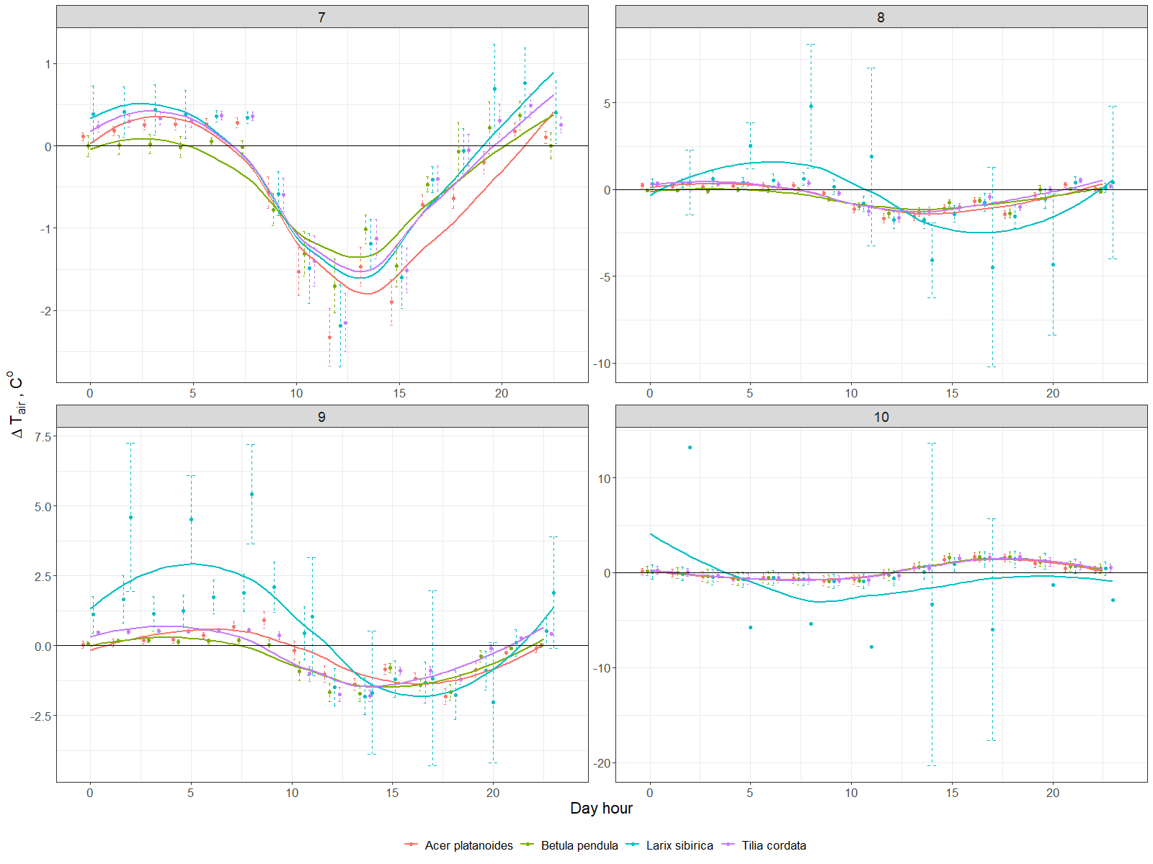

Figure 2.

There were no significant differences between this dynamics shown by species. But if we look at the average monthly differences – there are noticeable levels of the temperature reduction by the different species. During July the amplitude of temperature differences, associated with Betula, was lower than Acer, while Larix and Tillia show an intermediate same results. In August the maximal changes were shown by Larix. It’s very interesting, that during night time in September Larix was dissipating heat much higher than others – dT was around 2,5 ℃ degrees. Most of the species show a similar behavior, but Larix seems to show the highest excursions, probably due to trees crown geometry which is quite different form the broadleaves species. The opposite climate effect shown during October may be explained with leaf senescence and leaves fall (see LAI spectrometer data). In addition the relatively minor transpiration rates can also explain the changes in the energy balance of this period. These findings correspond well to Chen et al. (2019), who explained observed seasonal dynamics of temperature reduction rates by differences in transpiration and to Rahman et al. (2020), who also found that within the canopy radius of 4.5m of Acer platanoides or Tilia cordata trees, daytime temperature decreased up to 3.5 ℃ during August in comparison of the unshaded surrounding area.

The average differences between the air relative humidity under and outside of the canopy were not more than 20% (annex 1). During daytime trees made air more humid, while during nights they reduced humidity. There were no seasonal changes through months, even no significant difference between species. We can only see the typical sinusoid line with delay in time as a result of transpiration process.

Another important effect of trees is the mitigation of climate extremes. For this purpose we have estimated the daily differences between maximum and minimum temperatures of the reference station and the individual tree recording (fig. 3). While temperature amplitudes outside of the canopy (the black line) reached a maximum of about 10°C degrees in August, under the canopy this amplitude was 3°C degrees lower. All the species showed similar dynamics through the investigated period, but under the larch temperature extremes were more similar to the reference station particularly during fall after defoliation and due to the decrease of the air temperature.

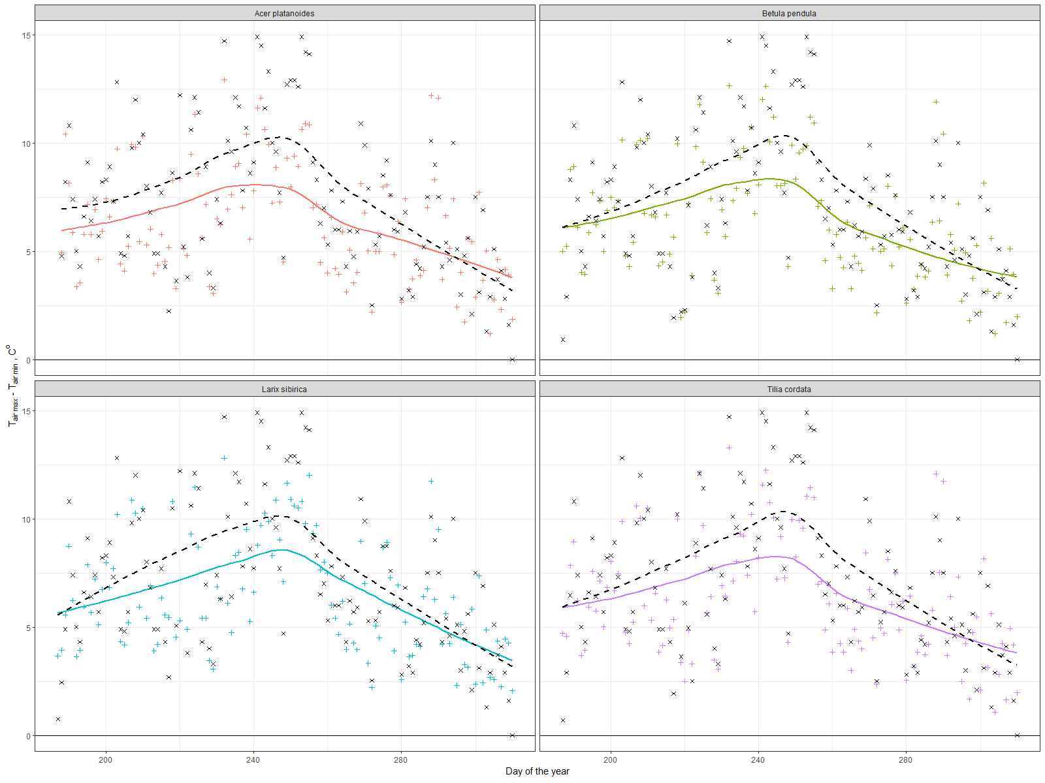

Figure 3.

Our results go in a line with the meta-analysis study, which showed relations between individual tree characteristics and daily/seasonal temperature reduction dynamics in different climate and urban conditions (Rahman et al., 2020). Temperature reduction by urban green infrastructure on about 0.5-2.5℃ degrees was also shown in several articles, which used computational modeling (Buccolieri et al., 2019; Morakinyo et al., 2020) and satellite based data such as land surface temperature (Kremer et al., 2016; Tonyaloğlu, 2020).

* 1. Carbon sequestration.

Carbon sequestration is the result of continuous diameter increment across the season, using the biomass equation with expansion factors. The growth dynamics show biomass increase till the end of September (around 260 day of a year) due to the warm autumn (Figure 2). Betula’s growing decreased two weeks later than others, with less variabulity across individuals, possibly because of more uniform young age. Acer #218A0281 had different dynamics with a rapid growth in the begginnig of the investigated period and then stopped growimg a month and a half earlier than others. This particular tree also showed the lowest VTA score, indicating possible declining patterns.

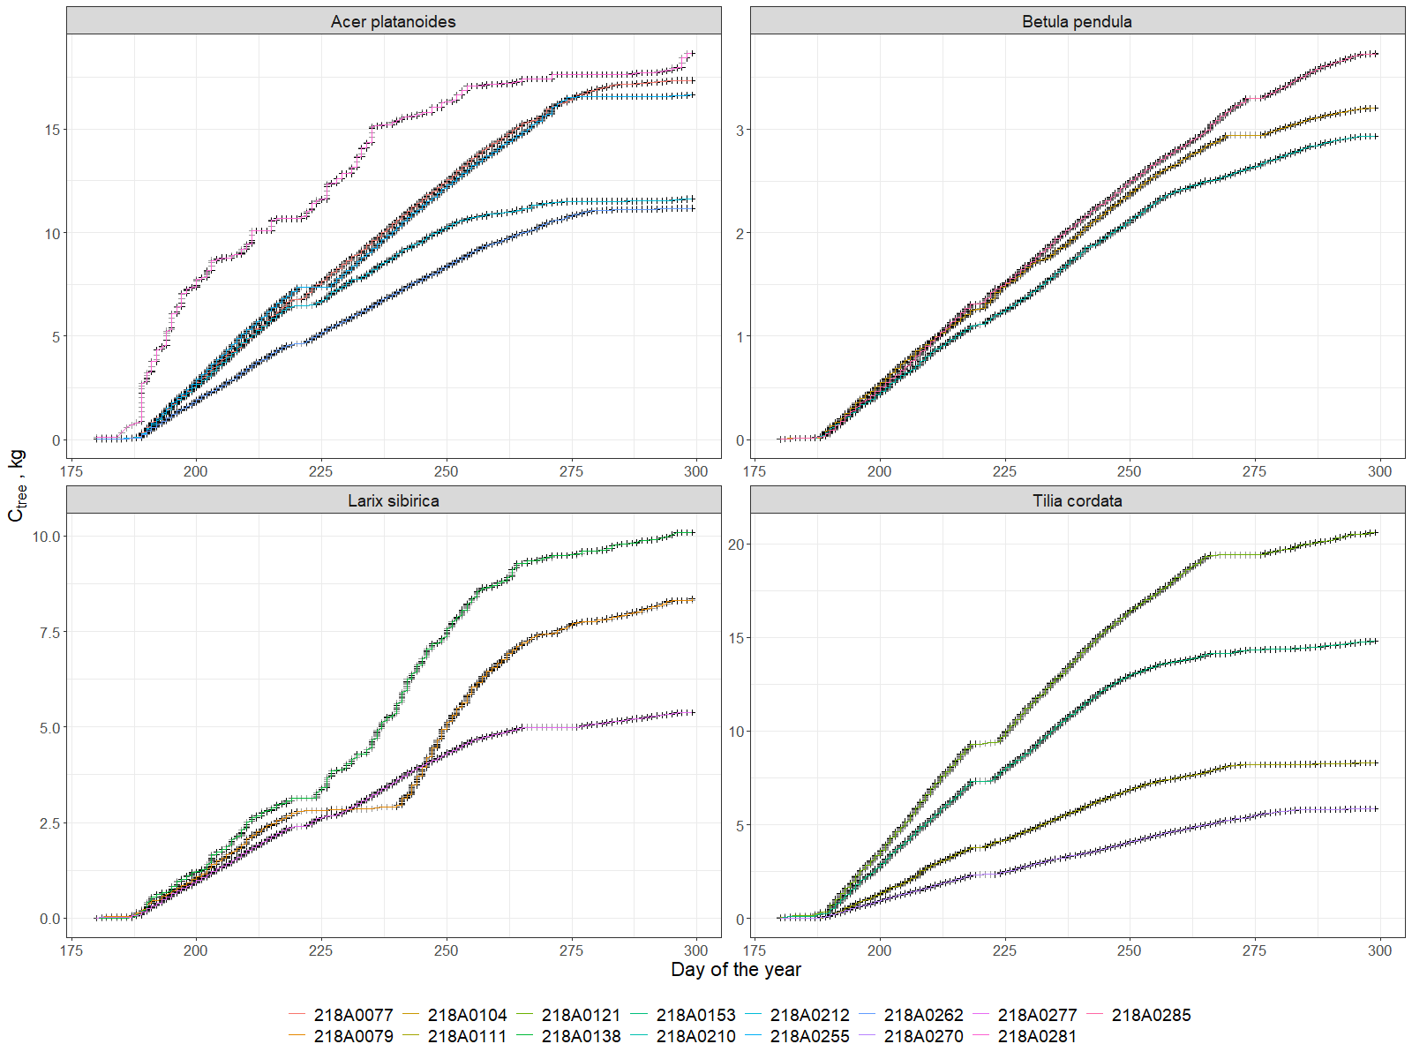

Figure 4. Cumulative grow of stored carbon for each tree.

In total the average accumalated carbon (during half of the vegetational season) was around 15 kg of Carbon for Acer spp. Larix accumalated about 7.5 kgC in average, and the lowest level was shown by Betula – 3kgC. The most diverse was Tillia – from 5 to 20 kgC that was related to the age and diameter. So, it is clear that diameter of the tree influence greatly the growth ratio and carbon sequestration as well.

* 1. Evapotranspiration

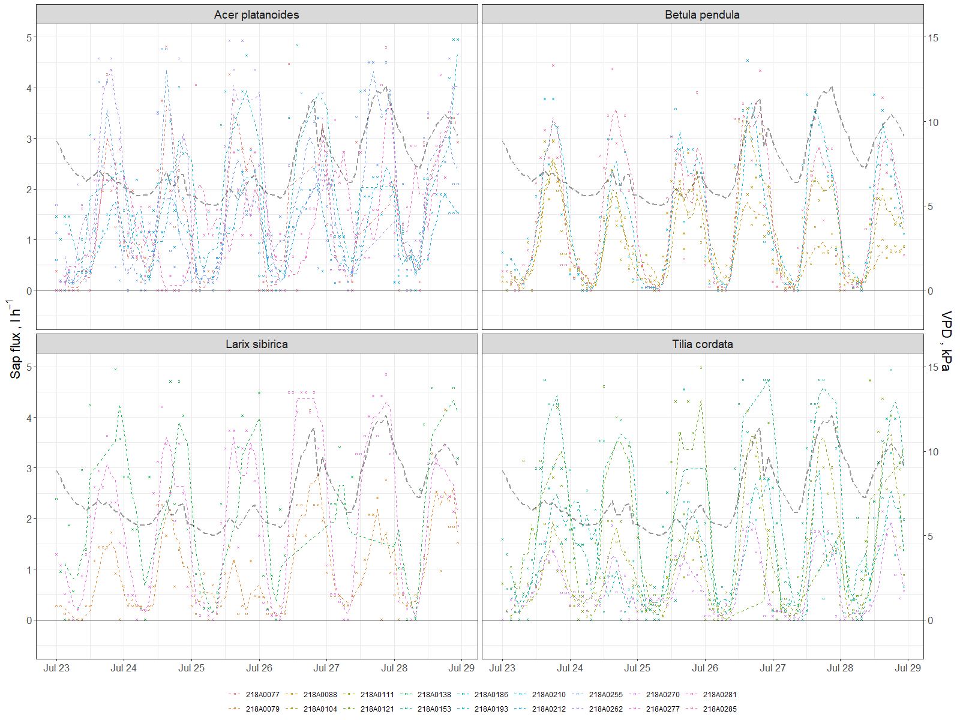

In fig XX we show an ensemble of transpiration daily patterns for the investigated individuals which show the typical diurnal behavior modulated by changing environmental parameters. For the purpose of the current study we report the cumulated transpired amount of water in relation to seasonal rainfall. The units are expressed in mm of water where for each of the tree, transpiration rates have been converted in mm by using the tree crown area (fig.5). The main purpose is to show, from ecosystem services perspective, the possibility of a tree to serve as a sewage system to mitigate flooding from rains. Our results show that Acers reduced 3-7 m3 of water through the investigated period, while Betulas – only 1- 3 m3. And again this clearly depends on the tree size. In general, this process seemed to be linear, but there were several noticeable deviations. If we assume that evapotranspiration depends only from diameter it should be no crossing lines on graph. It is clear that Acer #218A0262 and #218A0281 showed a similar trend until DOY 260 and from this date one of them slowed down, while the other became more active. Acer #281 has lower VTA score and higher diameter but he is standing in a group inside the square, while Acer #262 is standing on the edge, so maybe he was under a higher anthropogenic pressure. On the other hand there were no significant respond to the heavy rains. Our data shows that in general we can say that from 10 to 60% of water coming with the rains can be removed thanks to tree transpiration.

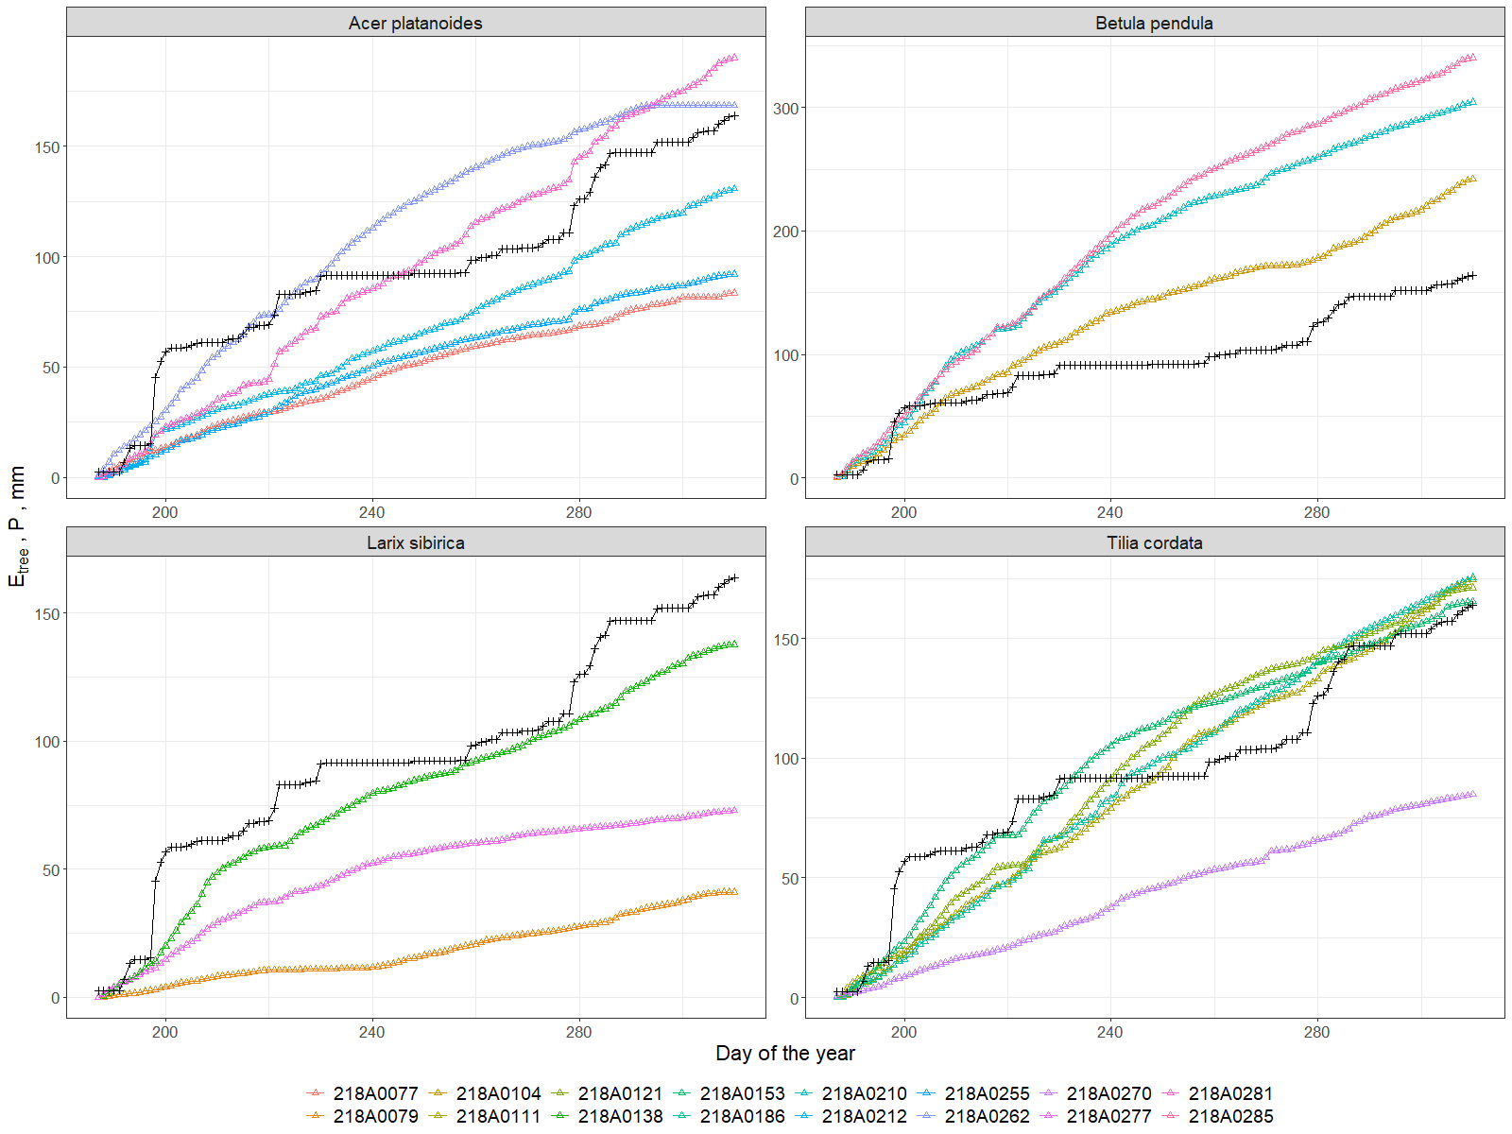

Figure 5. Evapotranspiration of each tree compared to precipitated volume for 50 m2.

* 1. Energy consumption

Using the energy balance equation it is possible to estimate the amount of absorbed radiation that is subtracted from the environment. Diurnal graph shows the increase of the absorbed energy (Rn) during day-time when evapotranspiration starts following the sun rise (fig.6). Energy flux associated with convective heating of a tree from the air was negative during night time (that means tree dissipate energy) during July and August. But it became positive already in September across all the day. And then in October energy flux at night became higher than day, which means tree takes more energy at night from the air. This reflects also in previous findings about changes in cooling effect in October. The lower values of energy absorption were shown by Betula and Larix, while Tillia and Acer showed the highest rates. It is interesting to note that Acer continue to be more active even in the first half of October, while all other trees dramatically drop down their activity. It is common to have the major part of energy absorption with transpiration during summer months, and convective heat during autumn.

Also the differences between individuals are noticeable (fig.7). For example Acer #218A0281 showed completely different energy balance structure than other Acers and very low total value during summer months, that can possibly by explain by his lowest VTA score. Acer #218A0262 was overheated during autumn months that can be related to his edge standing position on the southern border of the green area.

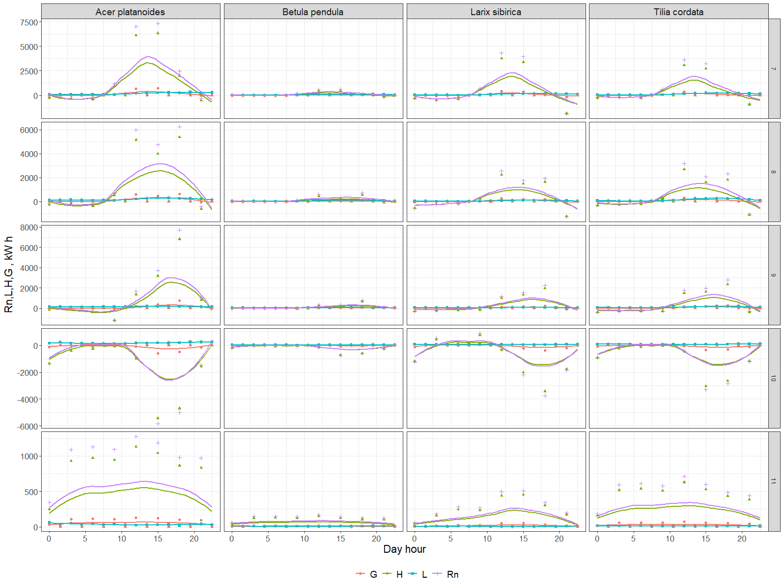

Figure 6. Average diurnal dynamics of Net energy absorption (Rn), sensible heat (H), latent heat (L) and soil heat (G) for different species averaged per month

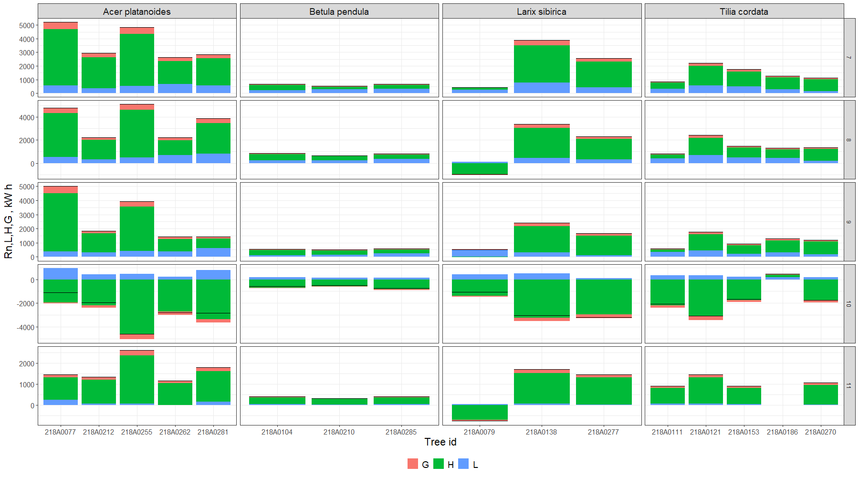

Figure 7. Energy removed from atmosphere monthly by each investigated tree - Net (Rn), due to sensible heat (H), latent heat (L) and soil heat (G)

* 1. LAI as a proxy for ES

The LAI dynamics is very important since it is a good proxy for several types of Ecosystem Services, such as wind velocity and noise reduction, pollution regulation and erosion protection via leaves as a buffer. Our results show that we can calculate summative canopy area index (PAI) that is just a sum from leaves and wood (bark) from the spectrometer data. Thus, due to the period with and without leaves we successfully obtained both indexes. These periods are clearly visible on a graph, and we can easily distinguish the time of defoliation which lasted one week in first days of October (fig.8). It is interesting to note that for an individual tree this process can take in reality one-two days. Only due to our perception of green areas as a whole we think this process has a slower dynamics.

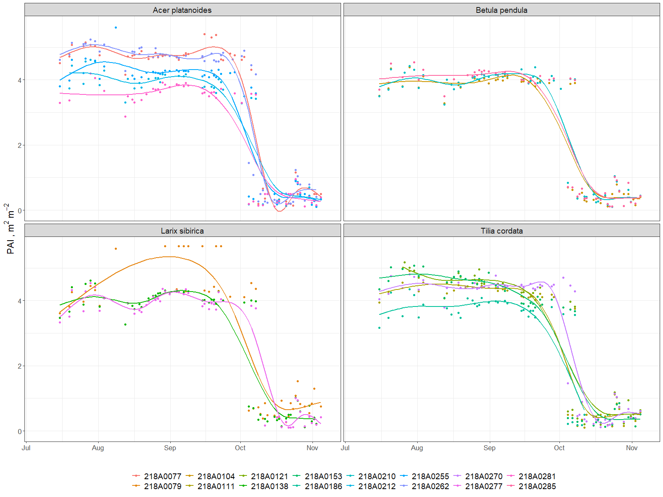

Figure 8. PAI dynamics during investigated period (July-November, 2019)

As a result PAI of all trees (table 4) was on average about 4 with less variation of Betula (3.0-3.2) and similar for Acer and Tillia (3-4). And even for Larix it was the same (3.4-3.7) despite our expectations; it can be possibly explain again with the higher insertion of the crown.

Table 4. Leaf and wood area indexes for each tree during investigated period

|  |  |  |  |  |  |  |  |  |  |  |  |  |  |  |  |  |
| --- | --- | --- | --- | --- | --- | --- | --- | --- | --- | --- | --- | --- | --- | --- | --- | --- |
|  | Acer platanoides | | | | | Betula pendula | | | Larix sibirica | | | Tilia cordata | | | | |
| **Tree ID** | 218A0077 | 218A0212 | 218A0255 | 218A0262 | 218A0281 | 218A0104 | 218A0210 | 218A0285 | 218A0079 | 218A0138 | 218A0277 | 218A0111 | 218A0121 | 218A0153 | 218A0186 | 218A0270 |
| **PAI, m2m-2** | 4.21 | 3.30 | 3.47 | 3.97 | 2.92 | 3.09 | 3.30 | 3.24 | 3.49 | 3.38 | 3.72 | 3.45 | 3.77 | 3.66 | 3.32 | 3.69 |
| **WAI, m2m-2** | 0.47 | 0.50 | 0.42 | 0.57 | 0.43 | 0.44 | 0.42 | 0.42 | 0.80 | 0.46 | 0.37 | 0.53 | 0.56 | 0.42 | 0.52 | 0.48 |
| **LAI, m2m-2** | 3.74 | 2.80 | 3.04 | 3.40 | 2.49 | 2.65 | 2.88 | 2.82 | 2.69 | 2.92 | 3.35 | 2.92 | 3.21 | 3.24 | 2.80 | 3.21 |

* 1. Particulate adsorption

Particulate adsorption is influenced by two main parameters – PAI and particulate concentration in air, according to the model described in Methods. The absorption dynamic during investigated period mostly reflected the changes in the air pollution level by particulate concentration, which shows peaks in the end of July and beginning of August, then in September and late November. While the reasons of this pollution dynamics were not in our focus, we can only say that the average absorption rates for all trees look similar and adsorption was on about 30 grams per day per tree (figure 9).

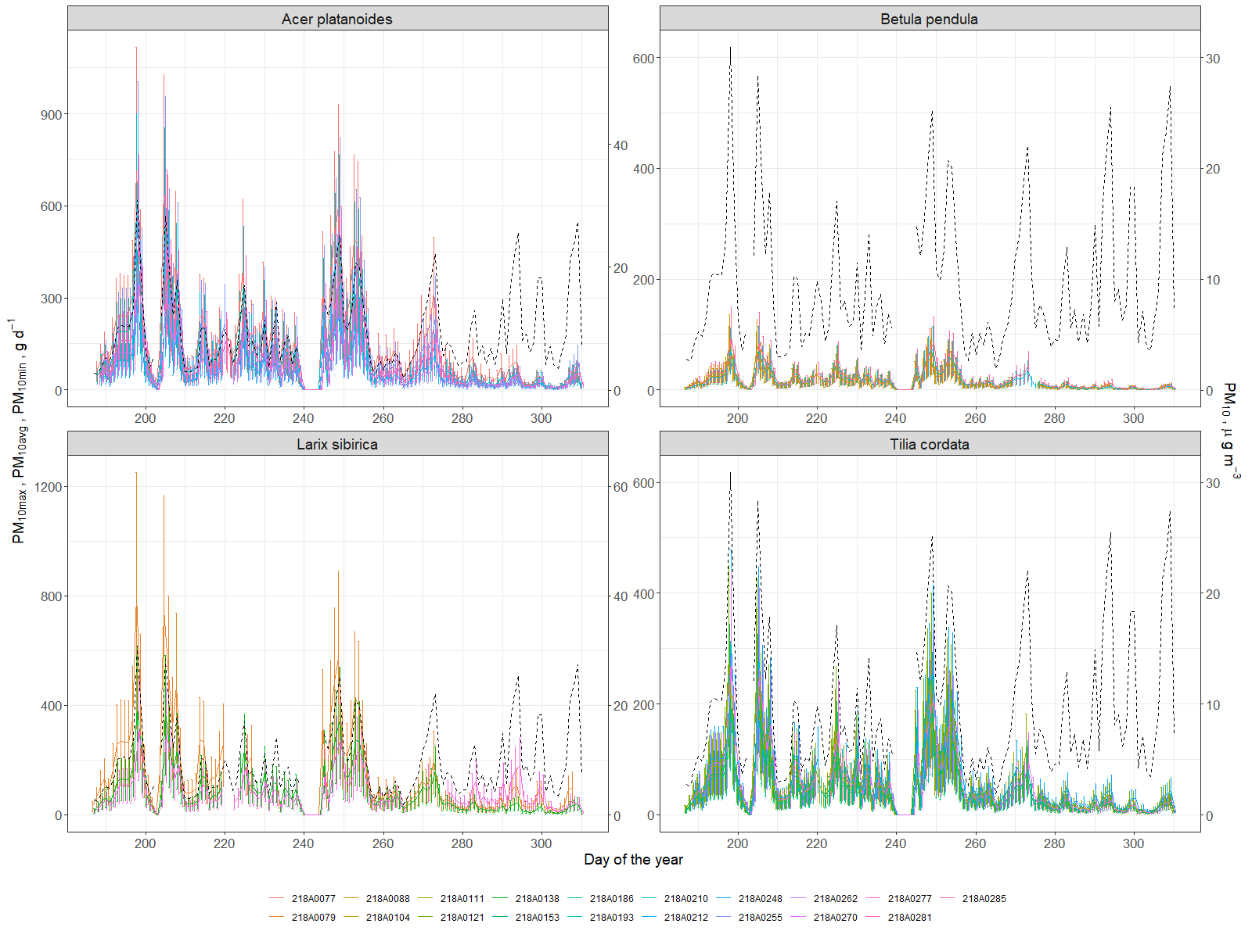

Figure 9.

At least, resulting the whole season the average mass of particles adsorbed was around 7kg for Acer, Larix, 4kg for Tillia, and around 1,3kg for Betula (fig.10). Sæbø et al. (2012) showed that Betula improves air quality by particulate adsorption much better than Acer and Tillia, that can be explained (in our case) just by the size of a tree. It is well known that healthy large trees remove about 60 times more pollution annually than healthy small trees (Nowak et al., 2006). And leaf wax or leaf hair density and topography also influenced much (Sæbø et al., 2012), but we do not take it into account, while our calculation was based on LAI. But the total adsorption by tree seems comparable with several works with the average 1-5 g m-2 rates of adsorption in different cities (Bottalico et al., 2016; Nowak et al., 2018; Selmi et al., 2016), which resulted in 30-200g daily per tree. Thus, our results from Moscow center with very high traffic look comparable.

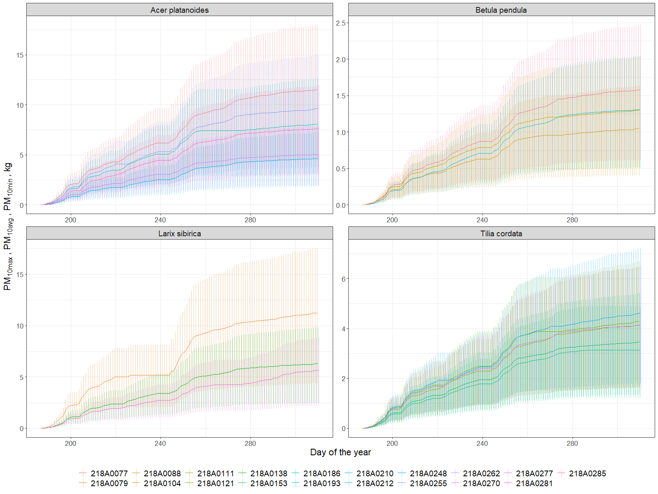

Figure 10. Cumulative particulate adsorption (minimum, average and maximum) by tree leaves per investigated period (July-November, 2019).

* 1. Main Ecosystem Services, provided by individual trees.

In table 4 we present a summary of data per species and different ecosystem indicators. According to our findings the tree average was 11.7 (+- 6.8) kg of Carbon stored, 160 (+- 82) mm of water transpired, 4908.56 (+- 4293.4) kWh spent for microclimate regulation and 5309.27 (+- 3235.44) g of PM10 adsorbed by average tree per investigated period (July-November, 2019). These results however show a quite large variability at individual level.

Table 4. Summative of ecosystem services produced by each tree per investigated period (July-November, 2019)

|  |  |  |  |  |
| --- | --- | --- | --- | --- |
| **Tree ID** | **Carbon stored, kg** | **Transpiration, mm** | **Energy absorbed, kWh** | **Adsorbed PM10avg, g** |
| Acer platanoides | | | | |
| 218A0077 | 17.46 | 83.59 | 15426.60 | 11504.62 |
| 218A0212 | 11.85 | 130.80 | 6389.32 | 4640.25 |
| 218A0255 | 16.85 | 92.10 | 11940.92 | 9641.40 |
| 218A0262 | 11.25 | 168.32 | 4598.44 | 5031.21 |
| 218A0281 | 20.62 | 190.09 | 7112.16 | 7641.87 |
| Betula pendula | | | | |
| 218A0104 | 3.25 | 242.16 | 1913.07 | 1298.78 |
| 218A0210 | 2.98 | 304.40 | 1484.26 | 1309.55 |
| 218A0285 | 3.79 | 340.33 | 1734.31 | 1579.61 |
| Larix sibirica | | | | |
| 218A0079 | 8.45 | 41.04 | -1845.99 | 11217.62 |
| 218A0138 | 10.43 | 137.62 | 8371.91 | 6287.91 |
| 218A0277 | 5.47 | 72.88 | 4822.87 | 5635.33 |
| Tilia cordata | | | | |
| 218A0111 | 8.39 | 174.45 | 1089.62 | 4130.52 |
| 218A0121 | 21.04 | 171.14 | 4762.70 | 4293.13 |
| 218A0153 | 14.98 | 165.41 | 3422.89 | 3459.32 |
| 218A0186 | 24.40 | 175.42 | 4340.69 | 3131.47 |
| 218A0270 | 5.91 | 84.88 | 2973.23 | 4145.75 |

**Conclusions**

Our results show that an IoT tree level network, using individual tree physiology sensing devices, such as TreeTalker, or other similar devices, can be used in principle for monitoring urban green infrastructure ecosystem services in real time.

The obtained measurement values are largely consistent with earlier publications on particulate adsorption and carbon sequestration (Nowak et al., 2018; Nowak and Crane, 2002). Trees energy losses had high variation between species, individual trees and seasons. Authors possess that main variability between individual trees was due to difference in size of the canopy and position of the tree in the plot. Nevertheless, there are not so much publication about energy balance of boreal urban trees, we got comparable number for lime in summer months. (Moser et. al, 2015). For investigated period individual trees was able to transpirate all precipitated water volume around them in area from 20 (*Betula pendula*) to 70m2 (*Acer platanoides*), which positively correlates with size and density of those species canopies. Taking into account density of the stand it can be assumed that for investigated plot annual rainfall and transpiration could be close for years without extreme rainfall ranges, what was shown for boreal urban trees of other cities (Rahman et al. 2019 , Riikonen et al. 2016). Such information obtained real time could considerably contribute to cities stormwater management (Scharenbroch et al. 2016)

Several indicators were calculated with certain assumptions or indirectly via proxy that lead to some uncertainties. Leaf Area Index, calculated from the spectrometer data was a bit lower than expected maybe because the entire canopy in the visible area of the sensor was not captured or was affected by close position of the device to the trunk. Thus, it is necessary to compare with standard technics (e.g. camera with fish-eye lens) more precise on the one hand. On the other – spectrometer, unlike the camera, allows the calculation of NDVI-type spectral indexes, which is also important for UGI monitoring to provide information about tree health. However, equipping the device with additional sensors may allow us to do measurements instrumentally in direct way. In particular, the installation of an anemometer will provide exact data on wind speed reduction, and sensors for particle matters and gases concentration in the air will boost our knowledge in the process of pollutants adsorption by the tree leaves in situ. It is also possible to use the microphones to assess the quality of the soundscape and the noise pollution reduction by the green infrastructure (Doser et al., 2020; Mydlarz et al., 2019) and to evaluate associated biodiversity with the help of recorded bird songs (Farina et al., 2014; Margaritis et al., 2018). Nevertheless, the technical development of sensors along with people engagement to citizen science will be inevitable (Nitoslawski et al., 2019; Schröter et al., 2017), thus it will be important to adapt them to the task of monitoring those parameters that are important for urban planning decisions (Cortinovis and Geneletti, 2019).

Among the indicators presented in the article, perhaps not all of them can be used for practical purposes directly. Air temperature and humidity under the canopy of city trees can be presented as is for people, as well as wind speed for example. However, in order to monitor the quality of the urban environment associated with green infrastructure, it is probably worth developing special scales of air quality, microclimate comfort and noise pollution levels – in this form it makes more clear information for citizens. On the other hand, for spatial planning tasks, annual or seasonal indicators of ecosystem services provided by one or another tree species at its specific age, height and condition will be more useful in the form of empirical data tables and spatial models, as it will affect which and where to plant trees (Bodnaruk et al., 2017). In addition, it is also necessary to take into account disservices associated with urban trees such as the fall of weakened and diseased trees on cars, infrastructure and buildings, and the allergic reaction of people to tree pollen (Speak et al., 2018; Teixeira et al., 2019). These parameters should also be continuously monitored and reported in real time for rapid response or timely prevention.

**6. Acknowledgements**

Monitoring and modeling ecosystem services of urban trees was supported by Russian Scientific Foundation Project # 19-77-300-12. Data processing and analysis was supported by “RUDN University program 5‐100.”

**7. Literature**

1. Aalders I, Stanik N (2019) Spatial units and scales for cultural ecosystem services: a comparison illustrated by cultural heritage and entertainment services in Scotland. Landscape Ecology 34:1635–1651. https://doi.org/10.1007/s10980-019-00827-6
2. Albino V, Berardi U, Dangelico RM (2015) Smart Cities: Definitions, Dimensions, Performance, and Initiatives. Journal of Urban Technology 22:3–21. https://doi.org/10.1080/10630732.2014.942092
3. Alonzo M, Bookhagen B, Roberts DA (2014) Urban tree species mapping using hyperspectral and lidar data fusion. Remote Sensing of Environment 148:70–83. https://doi.org/10.1016/j.rse.2014.03.018
4. Andersson E, Barthel S, Borgström S, et al (2014) Reconnecting Cities to the Biosphere: Stewardship of Green Infrastructure and Urban Ecosystem Services. AMBIO 43:445–453. https://doi.org/10.1007/s13280-014-0506-y
5. Andrea F, Bini C, Amaducci S (2018) Soil and ecosystem services: Current knowledge and evidences from Italian case studies. Applied Soil Ecology 123:693–698. https://doi.org/10.1016/j.apsoil.2017.06.031
6. Bettencourt LMA, Lobo J, Helbing D, et al (2007) Growth, innovation, scaling, and the pace of life in cities. Proceedings of the National Academy of Sciences 104:7301–7306. https://doi.org/10.1073/pnas.0610172104
7. Blanusa T, Garratt M, Cathcart-James M, et al (2019) Urban hedges: A review of plant species and cultivars for ecosystem service delivery in north-west Europe. Urban Forestry & Urban Greening 44:126391. https://doi.org/10.1016/j.ufug.2019.126391
8. Bodnaruk EW, Kroll CN, Yang Y, et al (2017) Where to plant urban trees? A spatially explicit methodology to explore ecosystem service tradeoffs. Landscape and Urban Planning 157:457–467. https://doi.org/10.1016/j.landurbplan.2016.08.016
9. Bolund P, Hunhammar S (1999) Ecosystem services in urban areas. Ecological Economics 29:293–301. https://doi.org/10.1016/S0921-8009(99)00013-0
10. Burkhard B, Maes J, Potschin-Young M, et al (2018) Mapping and assessing ecosystem services in the EU - Lessons learned from the ESMERALDA approach of integration. One Ecosystem 3:. https://doi.org/10.3897/oneeco.3.e29153
11. Czúcz B, Arany I, Potschin-Young M, et al (2018) Where concepts meet the real world: A systematic review of ecosystem service indicators and their classification using CICES. Ecosystem Services 29:145–157. https://doi.org/10.1016/j.ecoser.2017.11.018
12. Drobnik T, Greiner L, Keller A, Grêt-Regamey A (2018) Soil quality indicators – From soil functions to ecosystem services. Ecological Indicators 94:151–169. https://doi.org/10.1016/j.ecolind.2018.06.052
13. Dye C (2008) Health and Urban Living. Science 319:766. https://doi.org/10.1126/science.1150198
14. Elliott S (2016) The potential for automating assisted natural regeneration of tropical forest ecosystems. Biotropica 48:825–833. https://doi.org/10.1111/btp.12387
15. Farina A, James P, Bobryk C, et al (2014) Low cost (audio) recording (LCR) for advancing soundscape ecology towards the conservation of sonic complexity and biodiversity in natural and urban landscapes. Urban Ecosystems 17:923–944. https://doi.org/10.1007/s11252-014-0365-0
16. Frumkin H (2003) Healthy Places: Exploring the Evidence. Am J Public Health 93:1451–1456. https://doi.org/10.2105/AJPH.93.9.1451
17. Gómez-Baggethun E, Barton DN (2013) Classifying and valuing ecosystem services for urban planning. Ecological Economics 86:235–245. https://doi.org/10.1016/j.ecolecon.2012.08.019
18. Grimm NB, Faeth SH, Golubiewski NE, et al (2008) Global Change and the Ecology of Cities. Science 319:756. https://doi.org/10.1126/science.1150195
19. Guo Z, Zhang L, Li Y (2010) Increased Dependence of Humans on Ecosystem Services and Biodiversity. PLoS ONE 5:e13113. https://doi.org/10.1371/journal.pone.0013113
20. Haaren C von, Lovett AA, Albert C (2019) Landscape planning with ecosystem services: theories and methods for application in Europe
21. Haase D, Larondelle N, Andersson E, et al (2014) A Quantitative Review of Urban Ecosystem Service Assessments: Concepts, Models, and Implementation. AMBIO 43:413–433. <https://doi.org/10.1007/s13280-014-0504-0>
22. Hirabayashi, S., Kroll, C.N., Nowak, D.J., 2011b. I-tree Eco Dry Deposition Model Descriptions. http://www.itreetools.org/eco/resources/iTree_Eco_Dry_Deposition_
23. Model_Descriptions_V1_1.pdf (accessed 15.02.12.)
24. Kitchin R (2014) The real-time city? Big data and smart urbanism. GeoJournal 79:1–14. https://doi.org/10.1007/s10708-013-9516-8
25. Krausmann F, Lauk C, Haas W, Wiedenhofer D (2018) From resource extraction to outflows of wastes and emissions: The socioeconomic metabolism of the global economy, 1900–2015. Global Environmental Change 52:131–140. https://doi.org/10.1016/j.gloenvcha.2018.07.003
26. Kremer P, Hamstead ZA, McPhearson T (2016) The value of urban ecosystem services in New York City: A spatially explicit multicriteria analysis of landscape scale valuation scenarios. Environmental Science & Policy 62:57–68. https://doi.org/10.1016/j.envsci.2016.04.012
27. La Rosa D, Spyra M, Inostroza L (2016) Indicators of Cultural Ecosystem Services for urban planning: A review. Ecological Indicators 61:74–89. https://doi.org/10.1016/j.ecolind.2015.04.028
28. Lederbogen F, Kirsch P, Haddad L, et al (2011) City living and urban upbringing affect neural social stress processing in humans. Nature 474:498–501. https://doi.org/10.1038/nature10190
29. Lilly PJ, Jenkins JC, Carroll MJ (2015) Management alters C allocation in turfgrass lawns. Landscape and Urban Planning 134:119–126. https://doi.org/10.1016/j.landurbplan.2014.10.011
30. Lin J, Kroll CN, Nowak DJ, Greenfield EJ (2019) A review of urban forest modeling: Implications for management and future research. Urban Forestry & Urban Greening 43:126366. https://doi.org/10.1016/j.ufug.2019.126366
31. Lovell ST, Taylor JR (2013) Supplying urban ecosystem services through multifunctional green infrastructure in the United States. Landscape Ecology 28:1447–1463. https://doi.org/10.1007/s10980-013-9912-y
32. Lovett MG (1994) Atmospheric deposition of nutrients and pollutants in North America: an ecological perspective. Ecological Applications,4(4),1994, pp. 629-650.
33. Luederitz C, Brink E, Gralla F, et al (2015) A review of urban ecosystem services: six key challenges for future research. Ecosystem Services 14:98–112. https://doi.org/10.1016/j.ecoser.2015.05.001
34. Mascarenhas A, Ramos TB, Haase D, Santos R (2016) Participatory selection of ecosystem services for spatial planning: Insights from the Lisbon Metropolitan Area, Portugal. Ecosystem Services 18:87–99. https://doi.org/10.1016/j.ecoser.2016.02.011
35. Mesas-Carrascosa FJ, Verdú Santano D, Meroño JE, et al (2015) Open source hardware to monitor environmental parameters in precision agriculture. Biosystems Engineering 137:73–83. https://doi.org/10.1016/j.biosystemseng.2015.07.005
36. Mexia T, Vieira J, Príncipe A, et al (2018) Ecosystem services: Urban parks under a magnifying glass. Environmental Research 160:469–478. <https://doi.org/10.1016/j.envres.2017.10.023>
37. Monsi M, Saeki T. (1953). U¨ber den Lichtfaktor in den Pflanzengesellschaften und seine Bedeutung fu¨r die Stoffproduktion. Jpn J Bot. 14:22–52. [Republished in English: Monsi M, Saeki T. 2005. On the factor light in plant communities and its importance for matter production. Ann Bot. 95:549–567.]
38. Müller F, Burkhard B (2012) The indicator side of ecosystem services. Ecosystem Services 1:26–30. https://doi.org/10.1016/j.ecoser.2012.06.001
39. Mydlarz C, Sharma M, Lockerman Y, et al (2019) The Life of a New York City Noise Sensor Network. Sensors 19:1415. https://doi.org/10.3390/s19061415
40. Nitoslawski SA, Galle NJ, Van Den Bosch CK, Steenberg JWN (2019) Smarter ecosystems for smarter cities? A review of trends, technologies, and turning points for smart urban forestry. Sustainable Cities and Society 51:101770. https://doi.org/10.1016/j.scs.2019.101770
41. Njue N, Stenfert Kroese J, Gräf J, et al (2019) Citizen science in hydrological monitoring and ecosystem services management: State of the art and future prospects. Science of The Total Environment 693:133531. https://doi.org/10.1016/j.scitotenv.2019.07.337
42. Norton L, Greene S, Scholefield P, Dunbar M (2016) The importance of scale in the development of ecosystem service indicators? Ecological Indicators 61:130–140. https://doi.org/10.1016/j.ecolind.2015.08.051
43. Nowak DJ, Crane DE (2002) Carbon storage and sequestration by urban trees in the USA. Environmental Pollution 116:381–389. https://doi.org/10.1016/S0269-7491(01)00214-7
44. Nowak DJ, Crane DE, Stevens JC (2006) Air pollution removal by urban trees and shrubs in the United States. Urban Forestry & Urban Greening 4:115–123. https://doi.org/10.1016/j.ufug.2006.01.007
45. Nowak DJ, Hirabayashi S, Doyle M, et al (2018) Air pollution removal by urban forests in Canada and its effect on air quality and human health. Urban Forestry & Urban Greening 29:40–48. https://doi.org/10.1016/j.ufug.2017.10.019
46. Opdam P, Albert C, Fürst C, et al (2015) Ecosystem services for connecting actors – lessons from a symposium. Change and Adaptation in Socio-Ecological Systems 2:. <https://doi.org/10.1515/cass-2015-0001>
47. R Core Team (2020). R: A language and environment for statistical computing. R Foundation for Statistical Computing, Vienna, Austria. URL <https://www.R-project.org/>
48. Rahman, M.A., Moser, A., Rötzer, T. et al. Comparing the transpirational and shading effects of two contrasting urban tree species. Urban Ecosyst 22, 683–697 (2019).
49. Riikonen, A., Järvi, L., & Nikinmaa, E. (2016). Environmental and crown related factors affecting street tree transpiration in Helsinki, Finland. Urban Ecosystems, 19(4), 1693-1715. https://doi.org/10.1007/s11252-016-0561-1
50. Rötzer T, Rahman MA, Moser-Reischl A, et al (2019) Process based simulation of tree growth and ecosystem services of urban trees under present and future climate conditions. Science of The Total Environment 676:651–664. https://doi.org/10.1016/j.scitotenv.2019.04.235
51. Schröter M, Kraemer R, Mantel M, et al (2017) Citizen science for assessing ecosystem services: Status, challenges and opportunities. Ecosystem Services 28:80–94. https://doi.org/10.1016/j.ecoser.2017.09.017
52. Schwilch G, Lemann T, Berglund Ö, et al (2018) Assessing Impacts of Soil Management Measures on Ecosystem Services. Sustainability 10:4416. https://doi.org/10.3390/su10124416
53. Seto KC, Guneralp B, Hutyra LR (2012) Global forecasts of urban expansion to 2030 and direct impacts on biodiversity and carbon pools. Proceedings of the National Academy of Sciences 109:16083–16088. https://doi.org/10.1073/pnas.1211658109
54. Song XP, Tan PY, Edwards P, Richards D (2018) The economic benefits and costs of trees in urban forest stewardship: A systematic review. Urban Forestry & Urban Greening 29:162–170. https://doi.org/10.1016/j.ufug.2017.11.017
55. Speak A, Escobedo FJ, Russo A, Zerbe S (2018) An ecosystem service-disservice ratio: Using composite indicators to assess the net benefits of urban trees. Ecological Indicators 95:544–553. https://doi.org/10.1016/j.ecolind.2018.07.048
56. Spyra M, Kleemann J, Cetin NI, et al (2019) The ecosystem services concept: a new Esperanto to facilitate participatory planning processes? Landscape Ecology 34:1715–1735. https://doi.org/10.1007/s10980-018-0745-6
57. Teixeira FZ, Bachi L, Blanco J, et al (2019) Perceived ecosystem services (ES) and ecosystem disservices (EDS) from trees: insights from three case studies in Brazil and France. Landscape Ecology 34:1583–1600. https://doi.org/10.1007/s10980-019-00778-y
58. UNEP (ed) (2010) Mainstreaming the economics of nature: a synthesis of the approach, conclusions and recommendations of teeb. UNEP, Geneva
59. van Oudenhoven APE, Petz K, Alkemade R, et al (2012) Framework for systematic indicator selection to assess effects of land management on ecosystem services. Ecological Indicators 21:110–122. https://doi.org/10.1016/j.ecolind.2012.01.012
60. van Oudenhoven APE, Schröter M, Drakou EG, et al (2018) Key criteria for developing ecosystem service indicators to inform decision making. Ecological Indicators 95:417–426. https://doi.org/10.1016/j.ecolind.2018.06.020
61. Van Reeth W (2013) Ecosystem Service Indicators. In: Ecosystem Services. Elsevier, pp 41–61
62. Vihervaara P, Viinikka A, Brander L, et al (2019) Methodological interlinkages for mapping ecosystem services – from data to analysis and decision-support. One Ecosystem 4:. https://doi.org/10.3897/oneeco.4.e26368
63. von Döhren P, Haase D (2019) Risk assessment concerning urban ecosystem disservices: The example of street trees in Berlin, Germany. Ecosystem Services 40:101031. https://doi.org/10.1016/j.ecoser.2019.101031
64. Wilkinson C, Saarne T, Peterson GD, Colding J (2013) Strategic Spatial Planning and the Ecosystem Services Concept - an Historical Exploration. E&S 18:art37. https://doi.org/10.5751/ES-05368-180137
65. Willcock S, Hooftman D, Sitas N, et al (2016) Do ecosystem service maps and models meet stakeholders’ needs? A preliminary survey across sub-Saharan Africa. Ecosystem Services 18:110–117. https://doi.org/10.1016/j.ecoser.2016.02.038
66. Wissen Hayek U, Teich M, Klein TM, Grêt-Regamey A (2016) Bringing ecosystem services indicators into spatial planning practice: Lessons from collaborative development of a web-based visualization platform. Ecological Indicators 61:90–99. https://doi.org/10.1016/j.ecolind.2015.03.035
67. Wu J (2013) Landscape sustainability science: ecosystem services and human well-being in changing landscapes. Landscape Ecol 28:999–1023. https://doi.org/10.1007/s10980-013-9894-9
68. Zhao C, Sander HA (2018) Assessing the sensitivity of urban ecosystem service maps to input spatial data resolution and method choice. Landscape and Urban Planning 175:11–22. https://doi.org/10.1016/j.landurbplan.2018.03.007

Annex 1. Daily dynamics of the air temperature under and outside of the canopy

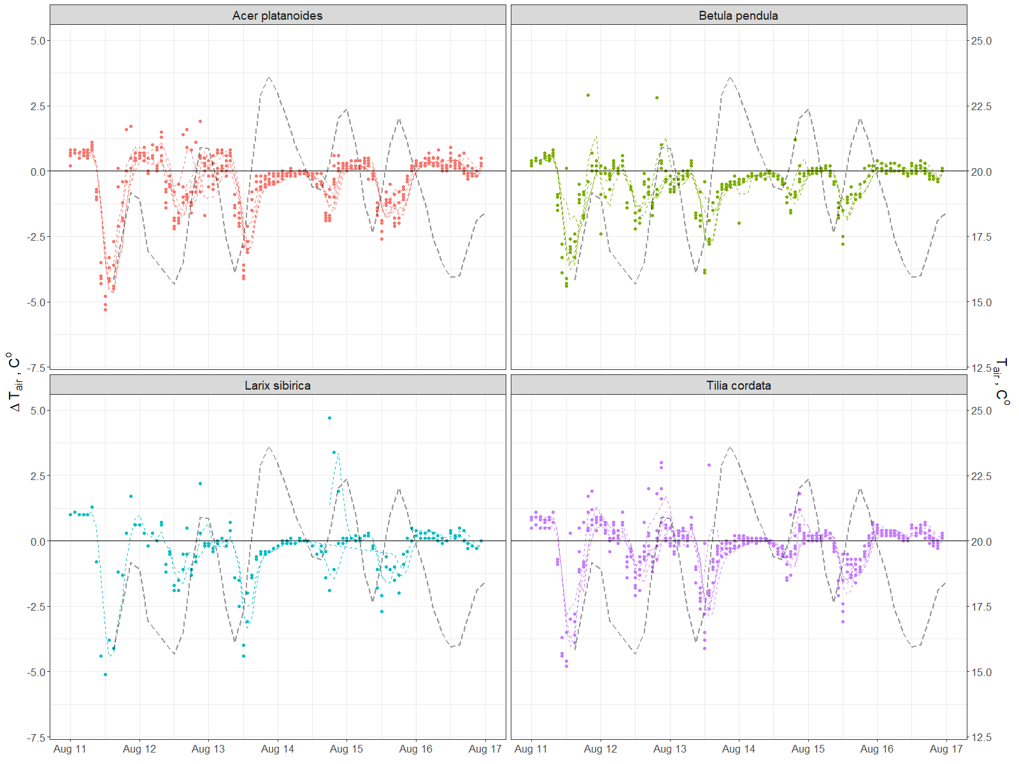

Annex 2. Daily and diurnal by month dynamics of the air relative humidity under and outside of the canopy

